**Stakeholder Objectives and Goals.**

My stakeholder is **Clinton Barton,** The Chief Financial officer of Shield Pharmacare.

Before we delve into identifying the Objectives and Goals of Clinton Barton, it is important to have a nascent knowledge of what Objectives and Goals means.

Objectives: Objects are most commonly referred to as a means to an end, they are the short term task or target that needs to be achieved to be able to actualize the bigger and broader task which is the Goal.

With that been said, Goals are the bigger or broader picture to achieve from the subsets of task executed and completed in a plan. In another word they are open-ended objectives

Having had the basic grasp of what Objective and Goals means, and apropos of Clinton Barton profile, we can now define his Objectives and Goal for Shield Pharmacare

**Clinton Barton Goals:**

Clinton goals for Shield Pharmacare is to increase growth and productivity, because this is his long term plan. A focus that should not be undermined, such focus usually gives birth to goals and Clinton Barton was not short of that.

**Goal:** Increase growth and productivity

**Clinton Barton Objective:**

After setting your goals, what next? what are the key task to undertake in other t achieve your goals? This and many others I believe were the questions Clinton had going on which gave Clinton an objective to maximize Shield Pharmacare investment profile through devising a means to increase employee commitment in company stock, and to reduce operational cost by alternating the best fit between Average working hours and Total working hours in the most possible and efficient way across the unit of Shield Pharmacare.

**Objective:** Maximize investment and reducing operational cost

**Target audience characteristics**

Usually this step surface from knowing your audience in other to align the key performance index in your presentation that best fit their professional objectives and goals, in the case Clinton Barton is my target audience. From reading through his profile with the aim of knowing more about him, I was able to inferred the below characteristics

* *Clinton is analytical*
* *Clinton Barton is learned*
* *Clinton is an expert in finance*
* *Clinton is experienced in operational efficiency*
* *Clinton Barton is innovative*
* *Clinton is a strategic thinker*

**Key data elements and metrics for data objectives, including rationale for their selection**

Having received the dataset from Shield Pharmacare Hr Department, studied it to understand the nature of the dataset. Going forward to selecting the key data element and metrics for data objective in relation to Clinton Barton.

|  |  |  |
| --- | --- | --- |
| Data Element | Metric for Data objective | Reason for Selection |
| Stock Option Level | **Timeliness:** This metrics measures how up-to-date or current our data element is; this is important because it tells us the current stock level of each employee which is salient for determining the current investment profile of Shield Pharmacare in the fiscal year  **Accuracy:** This measure how error free our data element is; this is also very important, because keeping accurate stock level record is paramount to the real reflection of Shield Pharmacare investment profile | Since Clinton Barton Goal of Growth through maximizing investment profile of Shield Pharmacare, Stock option level in our dataset is the closest to measuring investment commitment from the employees |
| Employee Turnover | **Representative:** This measure if the data element truly reflect or represent the true number of employees who left or stayed, it is important because it help to eliminate ghost-workers from the workforce which is again paramount in determining operational efficiency | It is a good element in determining Shield Pharmacare productivity through operation operational efficiency |
| Employee Total Working Hours | **Accuracy:** This measures how correct the employee working hours represent, this is important because it helps to eradicate dead hours; hours workers spent not working but getting paid.in the long run it ensures money is not wasted on idle hours | Again, the data element was selected because it is key in determining employee respective working hour in relation to their average working hour. This will assist Clinton to determine operational efficiency for improved productivity |
| Employee Average Working Hours | **Accuracy:** This measures how correct the employee average working hours represent, this is important because it helps to determine employee working overtimes | This data element was selected because it is pivotal in knowing overtime working hours which is very important to determine operational efficiency driving productivity |

**Metrics for business objectives, including rationale for their selection**

|  |  |  |
| --- | --- | --- |
| **Metric** | **Business objective** | **Reason for Selection** |
| Employee Total stock option/commitment | This metrics help to explain the total stake or commitment employee have in the business. This metric from the data set assist in understanding the investment level of employees in the company which in the long run is a key metric that drives business growth | To understand employee shareholding stake or investment in Shield Pharmacare |
| Workforce Turnover | To determine the number of employees who left the company or work. This assist in giving us a glimpse of employee average time in position which is good indicator of growth, work place efficiency, work place career development available to employees and productivity | To determine employee time in position and productivity |
| Workforce total working hours | To understand work overtime and pay roll calculations | Good metrics for determining employee productivity |
| Workforce Average working hours | To track overtime management | To check employee burnout and turnover, as well as employee job satisfaction |

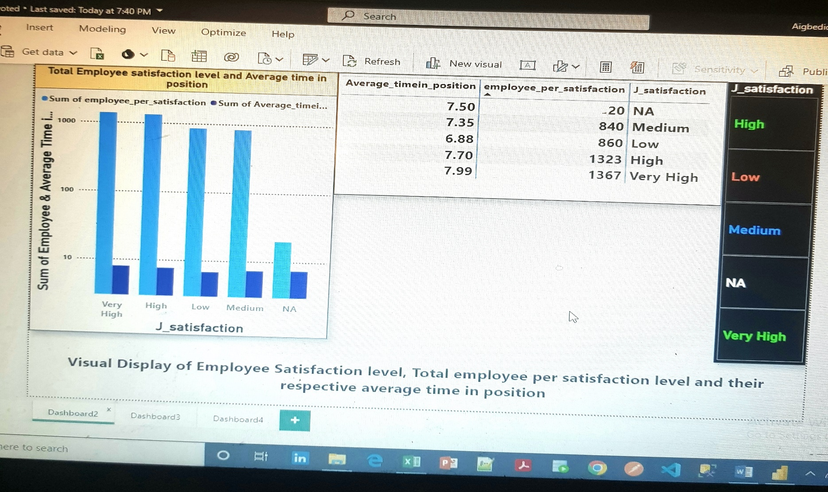**Draft visualizations for chosen metrics**

**Visualization 1**

Above is a dashboard of Shield Pharmacare Employee job satisfaction level, total number of employees per satisfaction level and their respective average time in position. There is a slicer to filter information per job satisfaction level.

**Visualization 2**

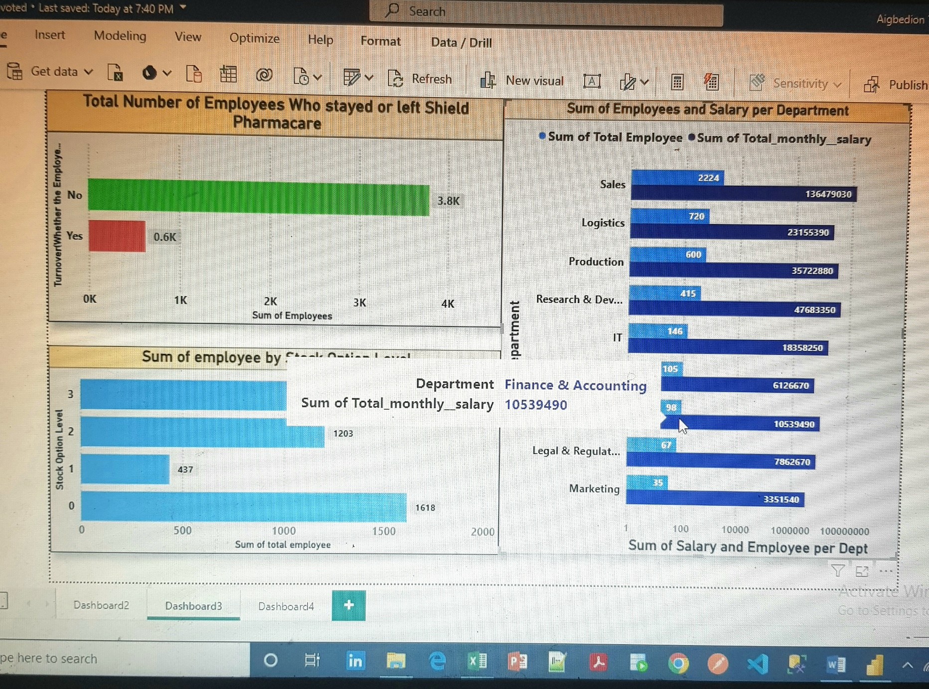

Above is visualization 2 which displayed at the first graph the Employee turnover at Shield Pharmacare, which means the total number of employee who stayed working with Shield Pharmacare and also those who left working for Shield Pharmacare. Going forward graph two displayed the respective stock option level of employee ranging from 0 -3 where 0 indicate the least level and 3 highest level.

The two graph mentioned above is a vital metrics Clinton Barton needs to be cognizance of, because they are good metrics that drives Company growth the more employee that stayed and the higher the stock level of employee the better growth Shield Pharmacare will experience and vice-versa.

Because Clinton Barton is a financial expert, Graph three was drafted to display the total number of employee per department and total departmental salary paid by Shield Pharmacare to their employees respectively. This is important because it gives Clinton Barton a glimpse of the total number of employees per department and also the expenses incurred on salary for each department which is a good metric that determines cost of operation, and cost of operation is vital to determine profit which is the closest direct indicator of growth

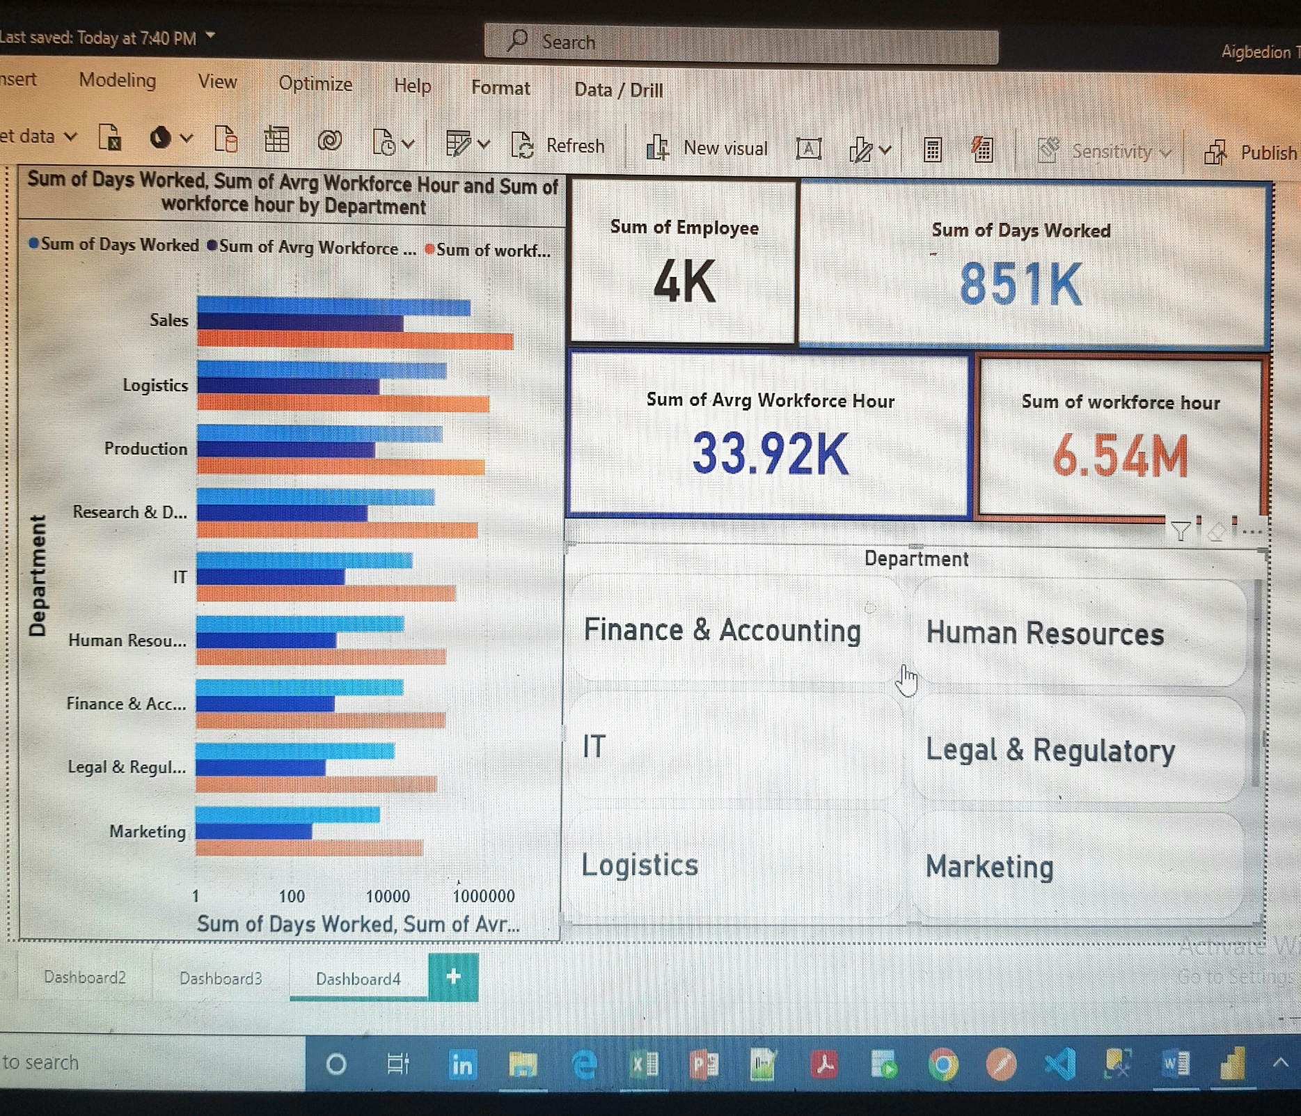**Visualization 3**

In Visualization 3, the focus was on operational efficiency aimed at increasing productivity, hence the metric Total Days Worked, Total Workforce Hour, Total Average Workforce Hour

The values of the above listed metrics in the visualization can give Clinton Barton an insight of how productive and efficient in operation each department is, in his case the financial and accounting department, this insight can come to lime light because studying closely the range or difference between Total Workforce Hour worked and Average Workforce hour to ensure the latter is always lesser than the former, and at the same time make sure overtime is not rampant to avoid employee burnout which in the long run will cause and adverse effect on productivity.